August 2023

Early Intervention Eating Disorders
  - AHSN national programme Final Report
  - April 2020-March 2023

Contents
Glossary 3
List of Figures and Tables: 4
Acknowledgements 5
Foreword 6
Executive Summary 7
About Academic Health Science Networks 9
Introduction 9
Clinical governance and accountability 10
First Episode Rapid Early Intervention in Eating Disorders 10
The FREED model 10
FREED journey to a national programme 11
The National Programme 12
Programme Governance 15
Benefits of FREED/EIED 16
Patient, Carer and Workforce Experience 17
Impact on patients and carers 17
Impact on staff 20
Engagement with partners 22
Inequalities 23
Challenges and support needs 24
Enablers 26
Involvement 27
Spread and adoption 28
Data collection 31
Training and shared learning 32
The AHSN role 33
Spread and adoption approach 34
Innovation 37
Sustainability 38
Key learning points for future programmes 40
References and evidence 43
Appendix 1. Feedback from AHSN Leads 46
Appendix 2. FREED spread and adoption by Mental Health Trust*: 50

Glossary
Term | Definition
AHSN | Academic Health Science Network - organisations which were set up in 2013 to spread innovation at pace and scale in the health and care system.
ED | Eating Disorder – a group of serious psychiatric disorders.
EIA | Equalities Impact Assessment – a method of assessing risk of health inequalities relating to a programme.
EIED | Early Intervention in Eating Disorders – name given to the AHSN national programme which commenced in 2020.
FREED | First episode Rapid Early intervention in Eating Disorders – model for ED treatment.
Global Majority | Group of people in the world who do not consider themselves or are not considered to be white and make up over 80% of the global population.
HIN | Health Innovation Network for South London – one of 15 AHSNs.
ICS | Integrated Care System – partnerships of organisations that come together to plan and deliver joined up health and care services.
KCL | Kings College London – University.
SLaM | South London and Maudsley NHS Foundation Trust – NHS Trust in South East London.
TAU | Treatment as Usual – the accepted treatment model prior or adjacent to FREED.

List of Figures and Tables:

Figure/Table Number | Figure/Table Title | Page Number
Table 1 | Enablers, Barriers and Learning | 7
Figure 1 | The FREED Model | 10
Figure 2 | Post-COVID rise in the number of children and young people starting eating disorder treatment within the year | 12
Figure 3 | Timeline of FREED from single centre to national programme | 14
Figure 4 | FREED in numbers | 16
Table 2 | Brief Patient Stories | 18
Figure 5 | % Patients of Global Majority in FREED services vs the General Area | 23
Figure 6 | Map of FREED spread and adoption by Service as at end March 2023 | 28
Table 3 | FREED service spread and adoption by AHSN as at end March 2023 | 29
Figure 7 | Number of FREED patients treated by month April 2020 to March 2023 | 30
Figure 8 | Aggregate number of FREED patients treated by month April 2020 to March 2023 | 31
Figure 9 | Spread and adoption methodology | 33
Table 4 | Example activities of the national programme team | 34
Table 5 | Example activities of local AHNSs | 36

Acknowledgements
The Academic Health Science Network would like to thank the following partners for their involvement in the Early Intervention Eating Disorders National Programme, as well as the many others who have contributed throughout the national programme:
- Service users and carers
- South London and Maudsley NHS Foundation Trust
- Kings College London
- Eating disorders service teams
- FREED Champions
- NHSE Community Mental Health Team
- The 15 Regional Academic Health Science Networks
- The Royal College of Psychiatrists
- All 42 Integrated Care Boards, and eligible Mental Health Trusts
- Beat Eating Disorders
- The Health Foundation
- Q Community

Foreword
It’s probably not necessary for me to outline here the devastating impact that eating disorders (EDs) have on people with EDs, their friends and their families. EDs are increasingly common, difficult to treat due to their complexity, and can result in a chronic illness that seeps into every fabric of their life. Recovery from an ED is always difficult, but is made even more so by the problems often faced when attempting to access services – particularly as EDs often become more severe (and therefore even more difficult to treat) whilst on a waiting list for treatment. The FREED programme has the proven potential to change this landscape – so that freedom from an ED and quick access to effective treatment becomes the norm, rather than the exception.
I first came across FREED in 2016 after asking my GP for help with my ED. Since then, it has been a privilege to be involved with FREED – first as a service user, then by continuing to help run the social media (@freedfromed) and present the FREED model to various organisations, and most recently as a member of the Programme Board. It is incredible to be able to acknowledge the positive impact FREED has had on me as an individual, but also to witness the spread of FREED and the 2430 patients (and their loved ones) who have been able to access this service, giving them the opportunity to realise their potential and experience life without an ED.
There are however still challenges, as this Final Report outlines. We still need to work with GPs, ED services and the wider general public to break the stigma around EDs – such as the misconception that they only affect young, white, thin women. We need to adapt to the very real operational challenges that are faced by services – such as funding and the ongoing effects of COVID-19. Yet the sheer brilliance, motivation and expertise of all who have been involved in the FREED Programme makes me incredibly confident that FREED will continue to thrive and spread, and that in the near future every person with an eating disorder will have the opportunity to access this lifesaving treatment, no matter where they live, or what type of ED they have.
- Georgina Partida, FREED Service User and Programme Board Member

Executive Summary
First episode Rapid Early intervention for Eating Disorders (FREED) is an evidence-based service model to provide developmentally informed, person centred early intervention for young people aged 16-25 within 3 years of eating disorder onset. Adolescence and early adulthood is unique in being the peak age for eating disorder onset as well as a time of neurodevelopmental change and significant life changes. The earlier an eating disorder is addressed the greater the likelihood of making a full recovery.
Developed by South London and Maudsley NHS Foundation Trust (SLaM) and King’s College London (KCL), early intervention in eating disorders (EIED) using the FREED model was selected by the Academic Health Science Network (AHSN Network) as a national programme for spread and adoption from 2020 to 2023 due to the evidence for its effectiveness and scalability.
The programme was coordinated by the Health Innovation Network for South London (HIN) as lead AHSN, and all 15 regional AHSNs worked with their local health systems to support adoption of FREED. The AHSN national programme, in partnership with SLaM and KCL, delivered:
- National spread of interest or adoption to all 54 eligible NHS Trusts
- Increased access to early intervention for eating disorders, with 2430 patients receiving FREED treatment
- Estimated cost savings to the NHS of £10.9 million
- Overwhelmingly positive feedback from FREED service users/carers, workforce and AHSN leads.
Throughout the national programme feedback from AHSN leads and eating disorder services reported a number of enablers and barriers to adoption, and strong themes for learning emerged which are set out in the table below:

Table 1. Enablers, Barriers and Learning

Enablers | Barriers
Enablers to spread and adoption of FREED include a compelling evidence base developed over several years in numerous sites. This worked alongside vibrant national, regional and local networks of ED service leads, clinicians, and AHSN leads to share learning, challenges and good practice. Robust evidence of efficacy, along with these networks, helped people feel part of a positive ‘movement’ and something bigger. Additionally, increasing recognition of the importance of early intervention at all levels (including within national NHS policy) paved the way for support in all regions. | Barriers to the spread and adoption of FREED include the impact of the COVID-19 pandemic, which struck at the time that the programme was due to commence. This resulted in significant disruption to ways of working and delivering care, as well as increased referrals. Also, recruitment is a significant challenge throughout mental health services, which impacted recruitment to FREED Champion posts as well as wider service readiness. Resourcing conflicts were reported as challenges in many areas, risking diversion of funding to other priority areas.
Learnings
Learning from the programme centred around the high value of relationship building, network building and shared learning. Further learning was that business case requirements and funding options to secure sustainability of services are something to be considered in detail at an early stage and adapted to an ever-changing budget landscape. Furthermore, data collection remains a challenge in terms of balancing consistent, detailed and accurate data to inform service development without making data collection onerous for already resource pressured services. Linked to this is the need to build in consistent collection of data on factors which can lead to health inequalities at national and local level in order to address the specific needs of under-served groups.

Despite the positive impacts of the rapid wide-spread adoption of the FREED model, and increased understanding of the benefits of early intervention, there is yet much to be done to ensure consistent access to age appropriate early intervention treatment for everyone who develops an eating disorder. The key recommendation of this report is that early intervention in eating disorders continues to be supported at national and local level as a strategic priority, and that the long term impact on service pressure is studied closely to inform future commissioning.

About Academic Health Science Networks
There are 15 Academic Health Science Networks (AHSNs) across England, established by NHS England in 2013 to spread innovation at pace and scale – improving health and generating economic growth. Each AHSN works across a distinct geography serving a different population in each region.
AHSNs connect NHS and academic organisations, local authorities, charities and industry and provide a range of practical support to facilitate change across health and social care economies, with a clear focus on improving outcomes for patients. AHSNs are uniquely placed to identify and spread health innovation at pace and scale; driving the adoption and spread of innovative ideas and technologies across large populations.

Introduction
Early Intervention Eating Disorders (EIED) was selected as a national spread and adoption programme across the Academic Health Science Network (AHSN) from April 2020 due to evidence for its effectiveness, scalability and alignment to NHS priorities. All 15 AHSNs were engaged with this national programme.
The specific approach selected was FREED (First episode Rapid Early intervention for Eating Disorders), a model developed by South London and Maudsley NHS Foundation Trust (SLaM) and King’s College London (KCL).
This report provides an overview of the National EIED Programme, its successes, learning and the challenges that AHSNs have experienced.
This short video explains the FREED programme in brief: Link to FREED video

Clinical governance and accountability
In programmes such as EIED, the AHSNs’ role is to encourage and support services and systems to adopt innovative practice. They do this through providing the evidence for effectiveness, sharing learning and convening relevant stakeholders. Clinical governance, as well as responsibility to adhere to the evidence based model and put in measures for service sustainability, remains with providers and commissioners.

First Episode Rapid Early Intervention in Eating Disorders (FREED)
FREED is a service model and care package, developed by SLaM and KCL to provide rapid treatment for 16 to 25-year-olds who have had an eating disorder for three years or less (anorexia nervosa, bulimia nervosa, binge eating disorder, or other non-specified eating disorders) (FREEDfromED, 2023). Eating disorders often develop between the ages of 15 and 25, which is a time of significant neurological development and life changes (Treasure et al, 2020) There is evidence that treatment for eating disorders is most effective during a window of 3 years from eating disorder onset (RCPsych, 2019; Schmidt et al, 2016; Austin et al, 2020). FREED aims to overcome barriers to early treatment and recovery and provides highly coordinated early care, with a central focus on reducing the duration of an untreated eating disorder.

The FREED model
FREED is structured to support eating disorder services, the FREED workforce, and patients (FREEDfromED, 2023). The model itself includes a number of evidence-based elements which are required for full fidelity to the model (Figure 1).

Figure 1. The FREED model: 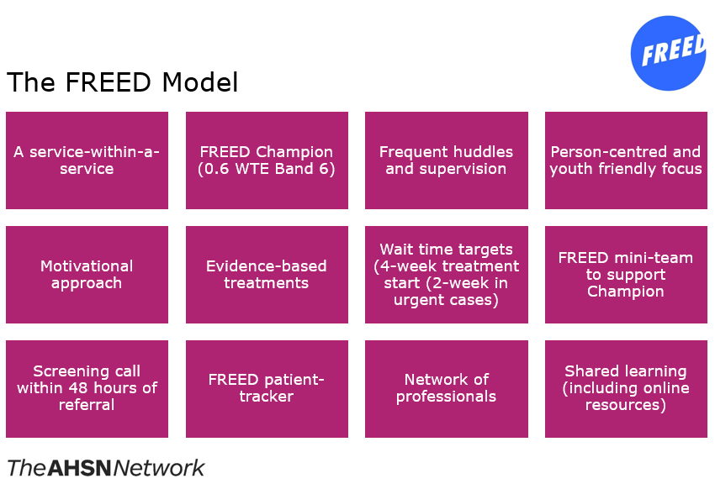

FREED journey to a national programme
The FREED early intervention in eating disorders model was inspired by the success of the existing Early Intervention in Psychosis model (NHS, 2023). FREED was initially launched in South London and Maudsley NHS Foundation Trust where it had been developed, followed by a further 3 sites, namely: Central and North West London NHS Foundation Trust; Leeds and York Partnership NHS Foundation Trust; and North East London NHS Foundation Trust. This initial spread was funded by The Health Foundation (Health Foundation, 2023).

FREED was evaluated against treatment as usual (TAU) in a single-centre, and a multi-centre study. These studies showed substantial reductions in duration of untreated illness and improvements in clinical outcomes and cost-savings (SLaM, 2015).

In 2017 a member of the FREED team at SLaM was accepted on to the NHS Innovation Accelerator, a programme which supports scaling up of promising innovations across the NHS (NHS Accelerator, 2017). FREED was further scaled from 4 to 8 services across 6 Mental Health Trusts with additional evaluation evidencing FREED’s efficacy and benefits (Flynn et al, 2020; Austin et al, 2020).

In 2020 FREED was selected as the model for the AHSN National Early Intervention Eating Disorders Programme. The selection process included development of ‘equivalence modelling’. This ensured the national programme was focused on spread of the most evidence-based model and provided a framework for comparison should another model emerge.

The National Programme
The Early Intervention Eating Disorder National Programme launched April 2020 with an aim to spread early intervention models of care for young people to 8 additional sites by the end of March 2021. However, during that year regional AHSNs had engaged with over 90% of eligible Mental Health Trusts which resulted in 16 new FREED sites across England and a further 18 sites in the process of implementing FREED with an anticipated launch date of summer 2021. At year end, 32% of Mental Health Trusts in England had adopted an early intervention model for young people diagnosed with an eating disorder.
Additionally, following the COVID-19 pandemic, it was clear that demand for ED services was significantly higher than at any time previously (Children’s Commissioner, 2023).

Figure 2. Post-COVID rise in the number of children and young people starting eating disorder treatment within the year (Children’s Commissioner, 2023).

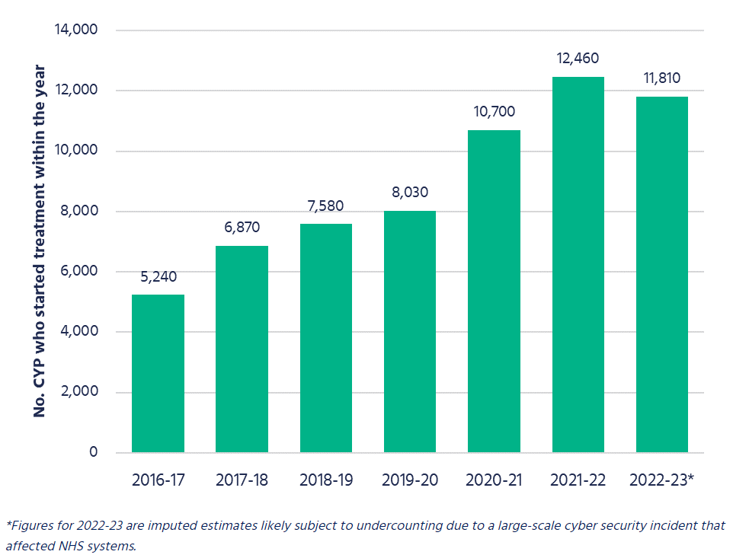
In February 2021 the AHSN national programme team led on a successful NHSE funding request of £430,000 on behalf of the SLaM FREED team, in recognition of the demand for rapid scaling of the programme. Additionally, funding was secured to provide 18 sites with £35,000 to recruit a FREED Champion, as well as ongoing implementation support delivered via SLaM/KCL to the 18 NHSE funded sites. New sites were supported with adoption through the Community Mental Health Transformation Funding (21/23), to cover training and supervision sessions and programme evaluation in 2022/23.
By early 2022 there was demand for spread to over 50 sites and £101,152 of funding was received from NHSE to continue the national programme for a third year. This funding was intended to enable full national spread and a final programme close date of March 2023.
An additional £240,064 funding was provided by the NHSE Community Mental Health team in 2022 to support delivery of two projects which were separate to the national programme, but adjacent and complimentary. These programmes were ‘Diversifying the FREED Workforce’ through recruitment of Experts by Experience in FREED services, and a ‘Transitions E-Learning module’ as a means of supporting consistency and best practice in transitions between children’s services to adult services, and university transitions. Both projects were in direct response to feedback from FREED services about their needs.
In 2023 funding was approved to support the central FREED network for a further year to allow time to develop a recurrent funding model, and plans to follow this period are in development.
The timeline of FREED development from a single centre to sustainable national spread is illustrated at Figure 3 below.

Figure 3. Timeline of FREED from single centre to national programme:

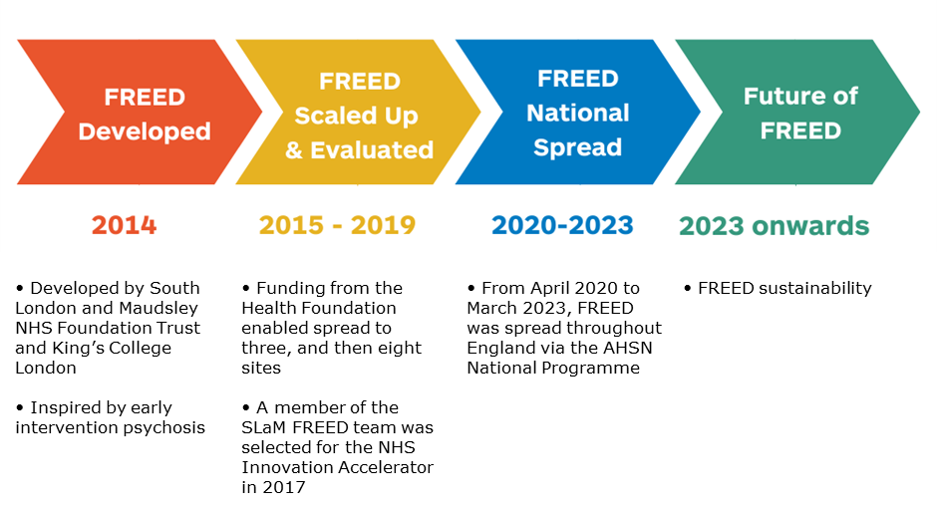

Programme Governance
Governance throughout the national programme was via a Programme Delivery Board comprised of an independent Chair, and representation from FREED service users, NHSE, SLaM, KCL, HIN and Beat Eating Disorders (UK eating disorders charity). The Board met quarterly and reported to the AHSN Network Operational Group to ensure continued alignment to the aims and objectives of the programme, namely:
- Earlier intervention and treatment of eating disorders in young people.
- Reduction in the duration of untreated eating disorders in young people.
- Reduction in waiting times.
- Improved clinical outcomes.
- Cost savings through reduced use of healthcare services, in particular reduced need for in-patient or day-patient admissions.
A key metric for measuring success of the programme was the number of patients seen compared to an agreed trajectory. The unanticipated impact of COVID-19 throughout 2020 – 2023 presented a significant challenge to meeting these forecasts due to disruption to treatment, staff and patient sickness, reprioritisation of NHS services during a time of national emergency, and an increase in referrals (Hyam et al, 2023). In the final year of the programme 1268 patients were seen against a trajectory of 1373.

Benefits of FREED/EIED
Multiple studies before and during the national programme show that FREED is robust and scalable (Brown et al, 2016; McClelland et al, 2018). As of the close of the national AHSN programme in March 2023, FREED is widely available to young people with eating disorders, delivering major improvements in patient care, experience, outcomes and value for money.

Compared to treatment-as-usual (TAU), FREED:
- Reduced waiting times by 32% for assessment and 41% for treatment (SLaM, 2015).
- Reduced the proportion of patients who needed day-patient or inpatient care by 35% (SLaM, 2015).
- Improved treatment outcomes such that 70% of FREED patients had symptom scores below clinical cut-off points by 12 months (vs. 50% on average in published studies)(Richards et al, 2023).
- Helped 59% of anorexia nervosa patients reach a healthy weight within 12 months of starting treatment, compared to 17% of non-FREED treatment-as-usual patients (McClelland et al, 2018, Austin et al, 2021).
- Reduced duration of untreated illness by 4-6 months (Brown et al, 2016; Flynn et al, 2020)
- Significantly improves treatment uptake (FREED: 98-100% uptake versus TAU: 71%) (Richards et al, 2023)
- Saw improvements to other clinical outcomes (mood, work and social adjustment) and carers show psychological improvements with FREED (McClelland et al, 2018; Austin et al, 2021).
- Significantly fewer FREED patients require intensive treatment (i.e. day treatment or inpatient admission) within 12 months of starting treatment (Austin et al, 2021).
- At 2-years post-referral, improvements in FREED patients remain markedly better than those of TAU, suggesting long-term impacts on patients’ well-being (Fukotomi et al, 2019).

Reduction in need for intensive treatment is estimated to result in average cost savings of £4,472 per patient treated with FREED compared with TAU (Austin et al, 2021). Additionally, reduction in need for in-patient treatment is estimated to have saved 800,000kg of carbon emissions in 2021/22, and reduction in need for both day case and in-patient treatment resulted in an estimated 110,000 days of workforce time saved in 2021/2022.

Figure 4. FREED in numbers:
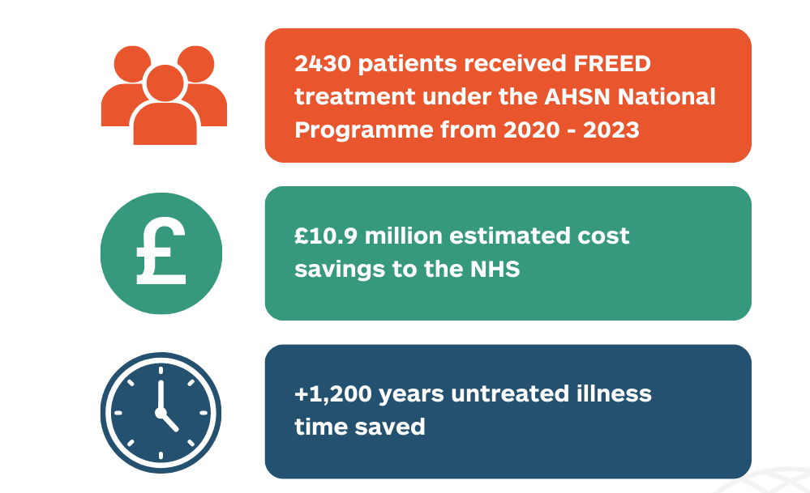

Patient, Carer and Workforce Experience
To evaluate how FREED impacted patients, carers and the ED workforce, qualitative data was collected by South London and Maudsley NHS Foundation Trust and Kings College London from over 100 FREED patients, and from 13 AHSN leads (Potterton et al, 2021; Hyam et al, 2023 submitted for publication). Further qualitative data was collected by the AHSN national programme from AHSN leads, FREED service teams and patients.

Impact on patients and carers
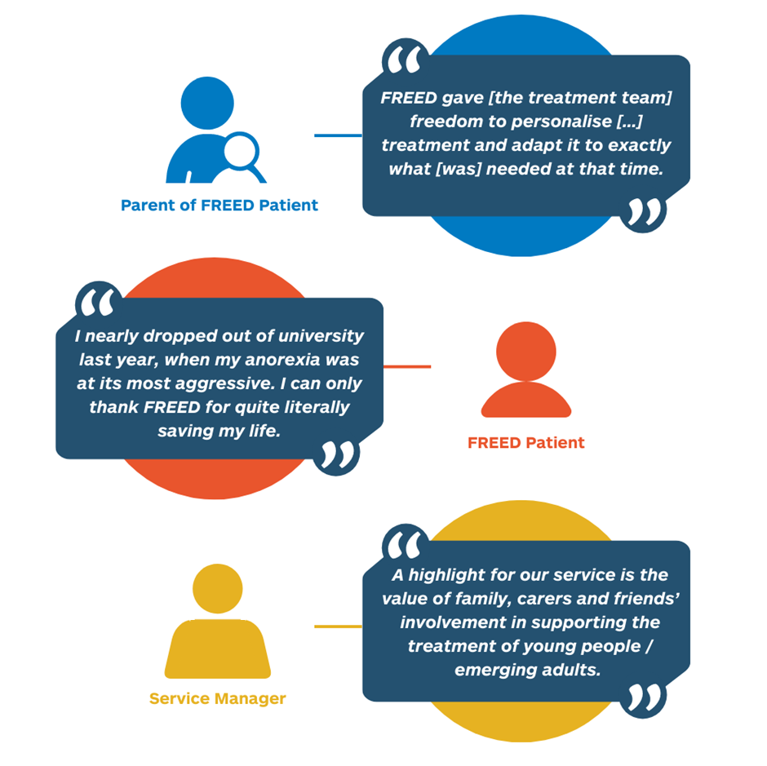
Data showed that the vast majority of patients and carers report positive psychological and behavioural changes and identify multiple beneficial characteristics of FREED treatment. Patients reported placing value on both the rapid access to treatment and the developmental adaptations of FREED (e.g. focusing on life beyond the ED, building a support network) which are integral to the FREED model.

Table 2. Brief Patient Stories:

Brief patient stories
“I would say that going to treatment saved my life really. I was told by my doctor that I wouldn’t make it through my 20s if I carried on in the way that I was acting. So, I think that early intervention in eating disorders is so crucial. You don’t want to waste your life, and in fact you do deserve food, and you do deserve to get better, and there is no shame.”

FREED Patient, KSS AHSN region

“I was restricting as much as possible, doing the most to get slimmer, and I just rapidly got worse […], until I realised at the end of the year, I needed proper help this time. I went to my GP […]. What is special about the [FREED] service is the fact that it has made a complete difference to my life and without the help I got, I wouldn’t be where I am today, recovered from anorexia, loving all that is food, and most importantly, loving life again.”
FREED Patient, West of England AHSN region
“There was such a risk with it that I would live a life that wasn’t mine, that was anorexia’s, and I’ve got it back. I completely feel like myself again […]. You enter such a risky place, and I think early intervention is so important. […] I’m fully recovered and I’m in such an incredible place in life, and I really, really wish and hope that everyone else who struggles will end up in that place, because it is possible.”

FREED Patient, KSS AHSN region

Impact on staff
FREED teams within ED services identified significant ‘buy in’ to the model and a sense that FREED increased staff hopefulness and motivation:

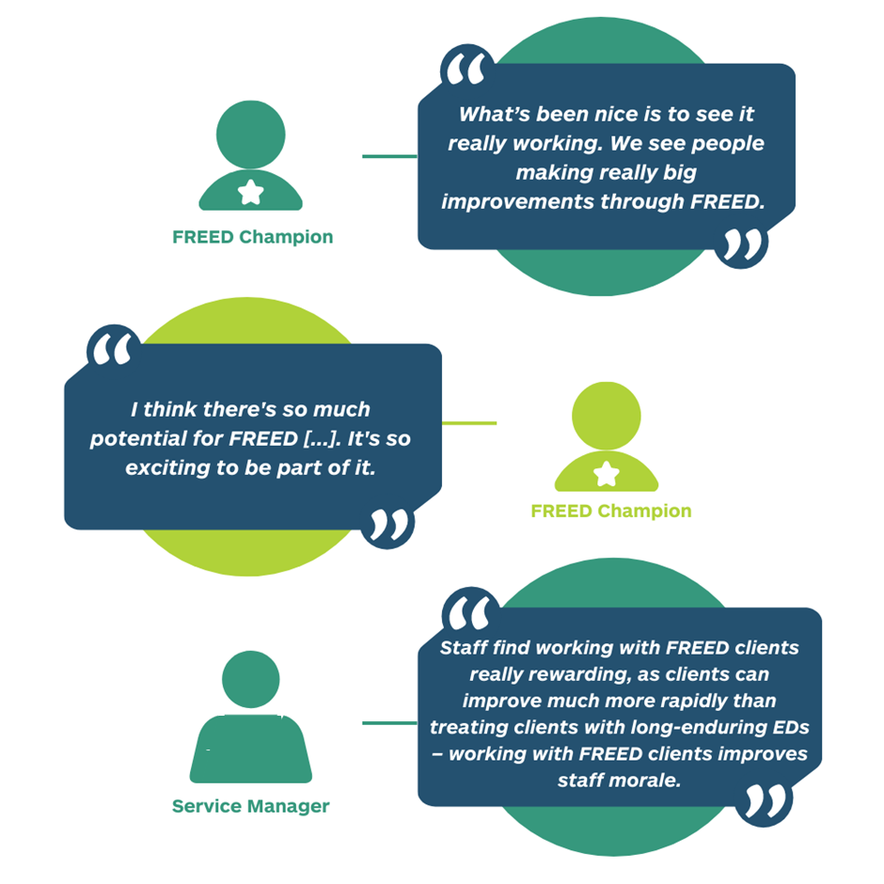

NHS eating disorder services in general are currently facing major difficulties in attracting and retaining staff, yet FREED services report that the model is a good way of attracting staff:

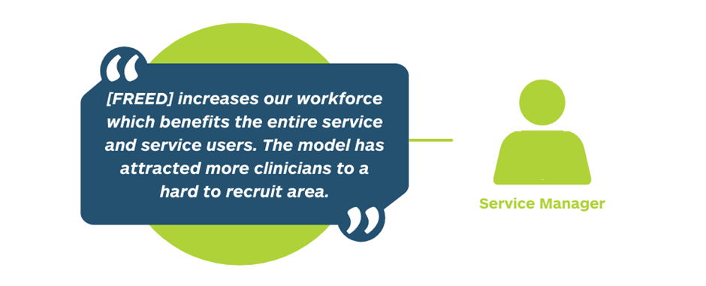

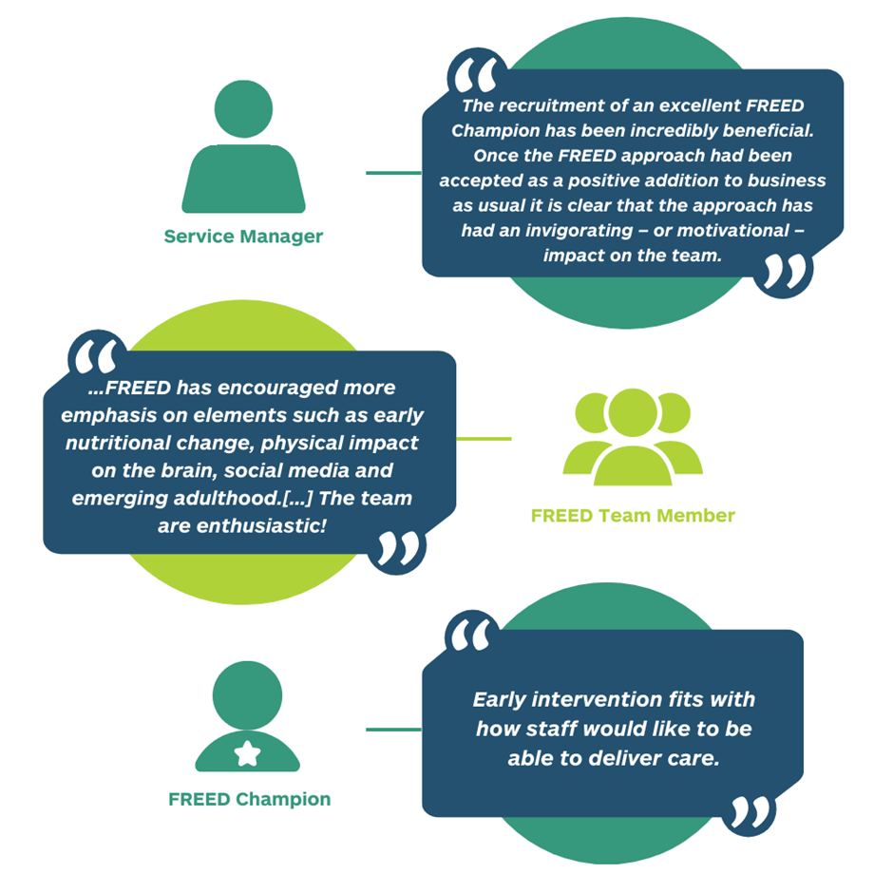
Furthermore, the national FREED programme resulted in additional recruitment to clinical posts. 18 FREED Champions were funded by NHSE, and regional AHSNs worked with local systems to support business case development and find sources of funding for other FREED team members.

Engagement with partners

In order to ensure early intervention takes place as early as possible, FREED services and AHSNs worked with local partners such as primary care networks and universities. This resulted in reports of greater collaborative working and greater understanding of the need for early intervention in eating disorders.

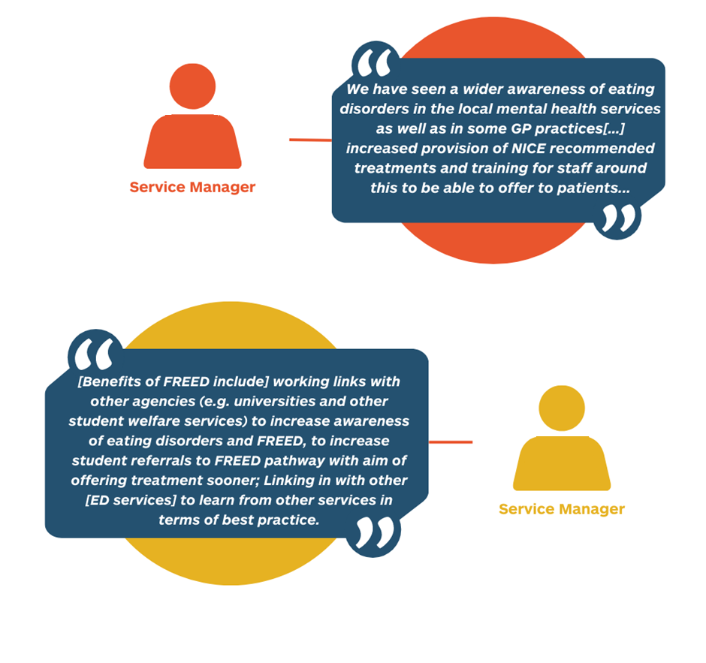
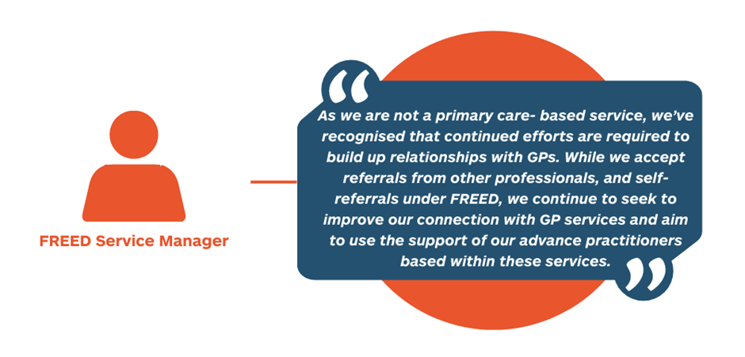

Inequalities
An equalities impact assessment (EIA) was developed for the FREED programme which considered the potential impact of the programme on age, disability, gender reassignment, race, pregnancy and maternity, religion and belief, sex, sexual orientation, marital/civil partnership status, vulnerability and other potentially relevant factors. In all applicable areas FREED was expected to have a positive impact based on national and local evidence.
AHSNs also encouraged local services to develop EIAs for their local service as part of implementation of FREED. AHSNs worked with many providers to complete EIAs, using the SLaM EIA as a template to be adapted locally. One AHSN (Kent Surrey and Sussex) developed a toolkit to support inequalities data collection locally and to share the learning nationally.
An inequalities toolkit developed by Kent Surrey and Sussex AHSN and applied locally discovered:

- There was a larger proportion of Global Majority patients within the FREED service compared to the population average in the areas the patients were from.
  - In Area ‘A’ (a county in South East England), 40% of FREED patients were of the Global Majority compared to 20% of the population within the area.
- The gender split of patients was over 10 females for each male (10:1). Research indicates that this is typical of an eating disorder service, but highlights an area for future exploration.

Figure 5. % Patients of the Global Majority in FREED services vs the General Area (*data prepared by Kent Surrey Sussex AHSN / Unity Insights Ltd):

Area A

Area A

Area B

Area B

Area A

Area A

Area B

Area B

Challenges and support needs
National spread, which commenced in April 2020, was hindered significantly by the COVID-19 pandemic which emerged at the same time. COVID-19 pandemic response hindered usual ways of working through social distancing measures and staff sickness, and resulted in a significant (40%) increase in referrals (Hyam et al, 2023). Additionally, AHSNs met challenges with spread due to some services being unable to recruit to the FREED Champion post, with recruitment being a challenge in Mental Health Trusts in general especially in rural or high-cost areas. Some areas experienced staffing challenges where there was a prioritised need to deploy staff to inpatient settings. Example quotes on challenges from FREED services and AHSN Leads include:

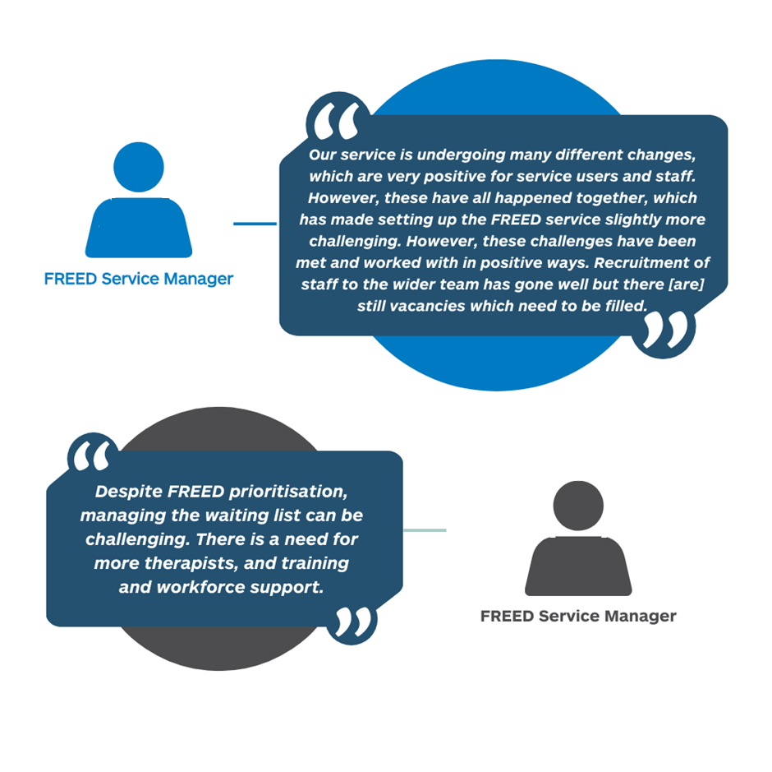
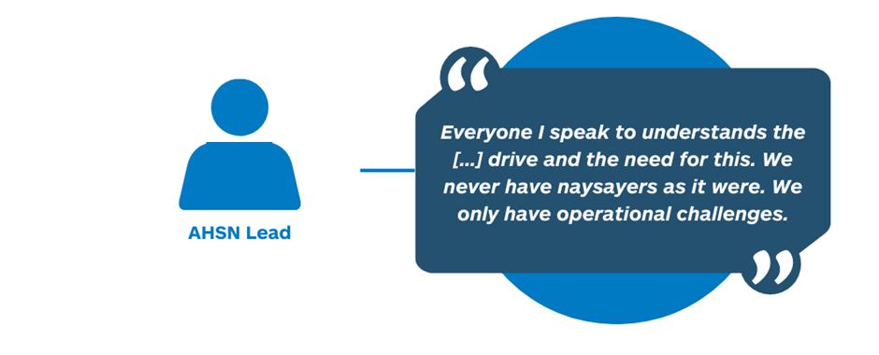
In terms of future support needs, a survey of all FREED services, which received 21 responses, listed the following needs:
- Network and group supervision.
- Continued funding.
- Continued recruitment to FREED roles.
- Continued senior management support/strategic prioritisation.
- Further resources to support early intervention.
- Support from other services who have successfully implemented.
- Ongoing review of resourcing against demand.
- Allocation of funding towards a mini-FREED team.
- Ongoing support from the AHSN.
- Ongoing support from the community of practice network.
- Access to continued training.
- Increased accessibility for service users.
- Continued FREED implementation supervision.
- Support with evaluation.
- Funding to help increase provision to areas which are not yet in scope.
- Shared learning on issues such as transition, social media, independence.
- Continued supervision to promote adherence to the model.
- Research to promote knowledge and share outcomes.
- Increased links to CAMHS.
Some needs, such as funding, recruitment and training were raised multiple times.

Enablers
Policy enablers included FREED being cited in NHSE’s Community Mental Health Transformation plan, as well as reduced wait times being referenced as a goal in the NHS Mental Health Implementation Plan (2019). Increased investment in early intervention in eating disorders was also highlighted as a goal in the NHS Community Mental Health Framework for Adults and Older Adults (2019).
Enablers during the programme included reported satisfaction with the network approach to delivery, with communities of practice being reported as particularly beneficial. Other positives included regular shared learning webinars and the NHS Futures page, and FREED Network Website (maintained by SLaM/KCL) repository of implementation materials and implementation supervision provided by SLaM/KCL.
Additional enablers were the support of the AHSN national programme in obtaining NHSE funding for 18 services to receiving funding for a FREED Champion, and other services receiving support through their local AHSN with either business case development or localised ‘pump prime’ funding. This allowed services to start their FREED service, which in turn enabled them to see the benefits of FREED and make a case for continuity.
The AHSN approach to relationship development further bridged gaps between services and commissioners so FREED could be better prioritised at Integrated Care Board/Integrated Care System level. AHSNs were able to share persuasive evidence for the effectiveness and benefits of FREED with budget holders and clinicians, and share learning from services who had already adopted. Additionally, where necessary and appropriate, AHSNs were able to escalate challenges requiring support such as specific resource pressures.
Recruitment proved a challenge in most services and AHSNs were able to support in many cases by assisting with job description development, sitting on recruitment panels and helping services consider a skills mix that would widen access to the role while maintaining fidelity to the requirements of the FREED model and patient safety.

Involvement
Individual patients and carers and Beat Eating Disorders were represented on the FREED Programme Board to contribute at decision making level. Other examples of patient involvement are:

- Patient as co-chair of FREED implementation group.
- Eating Disorders Lived Experience Advisory Panel.
- FREED learning events led by or involving patients and carers.
- Experts by experience sitting on FREED Champion interview panels.
- Meetings with Parent and Carer Collaboratives.
- Community engagement work to improve access to FREED for under-served populations.

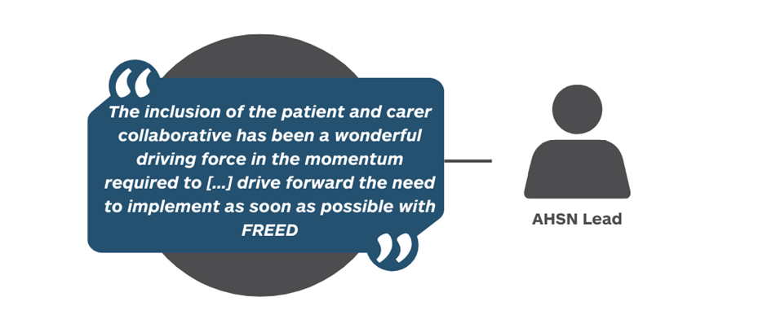

Spread and adoption
The AHSN national programme in partnership with SLaM and KCL has resulted in FREED being available or at a stage of implementation in 57 ED services nationally.
The AHSN Network defines the stages of adoption as:

- Adoption - currently deliver an active FREED service
- Implementation - in the process of setting up a FREED service (i.e. actively recruiting a FREED Champion)
- Interested - exploring how they can set up a FREED service with the intention of doing so, but may be facing specific challenges at present.
- Knowledge – AHSNs have had discussions with the Trust or service about the innovation.
- Decision – currently unable to adopt the innovation but may well be actively working to change this.
- Of 54 eligible Mental Health Trusts:
48 have adopted or commissioned the FREED model (full or partial)
6 are at a stage of preparation for adoption
0 have permanently elected not to adopt

Figure 6 and Table 3 below show a picture of spread and adoption of FREED as at end March 2023.

Figure 6. Map of FREED spread and adoption by Service as at end March 2023*

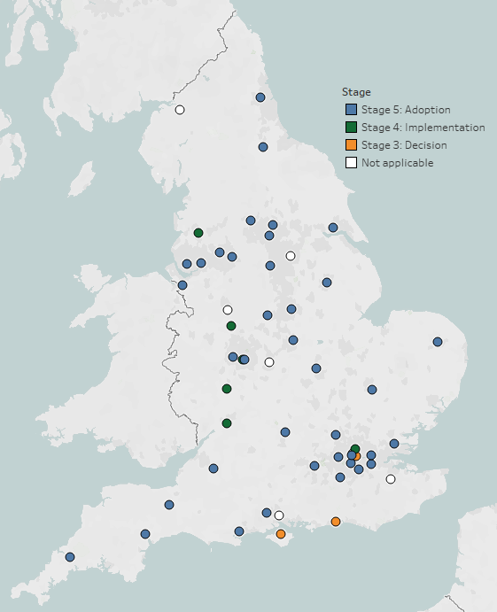

Table 3. FREED service spread and adoption by AHSN as at end March 2023*:

AHSN | Adopted (full or partial) | Developing / Implementing | Interested /Decision | Not applicable
East Midlands | 5
Eastern | 3
Health Innovation Manchester | 4 |  |  | 1
Health Innovation Network | 3
Imperial College Health Partners | 2
Innovation Agency | 3 | 1
Kent Surrey and Sussex | 2 |  | 1
North East and North Cumbria | 2 |  |  | 1
Oxford | 2
South West | 4
University College London Partners |  |  |  | 1
Wessex | 2 |  | 1 | 1
West Midlands | 2 | 2 |  | 2
West of England | 1 | 1
Yorkshire and Humber | 7 |  | 1 | 2
Total | 42 | 4 | 3 | 8
*Based on information provided April/May 2023. Number of Services differs from number of Mental Health Trusts. Services noted as ‘not applicable’ may commission eating disorder services from a separate provider. Services noted as ‘decision’ temporarily lack resource to adopt. For full up to date Service-level information contact Services directly.

Data collection
Data collection for a national programme covering multiple Trusts, providers, services and sites at varying stages of adoption is complex and challenging. The AHSN national programme commissioned a data insights provider to collate quantitative data on spread and adoption of FREED throughout the duration of the programme, which was reported to the data insights provider by regional AHSNs on a quarterly basis.

Further quantitative data was collected by SLaM and KCL on how many patients had been referred to services, how many were eligible for FREED, and how many patients were treated by services on a quarterly basis (see Figures 7 and 8 below).

Figure 7. Number of FREED patients starting treatment by month April 2020 to March 2023 (duration of the national programme only):

Figure 8. Aggregate number of FREED patients starting treatment by month April 2020 to March 2023 (duration of the national programme only):

Further, qualitative data was collected throughout the life of the programme from service users, carers, workforce and AHSN leads by SLaM, KCL and the AHSN national programme team. This data was collected via surveys, individual interviews, and discussion at communities of practice or other opportunities.

Training and shared learning
A key feature of the success of the national programme has been the training and education sessions received by FREED services provide by SLaM, KCL and AHSNs.

When the national programme concluded at the end of March 2023:

- 2900 clinicians had accessed online FREED training delivered by SLaM/KCL.
- 15 training days for services implementing FREED were delivered by SLaM/KCL between 2020-23 (460+ NHS clinicians overall).
- New online resources were developed and shared via NHS Futures, the FREED website and other communications.
- Webinars were hosted by the AHSN national team on various topics, with speakers from SLaM/KCL and other FREED experts.
- A large hybrid (in-person and online) FREED conference was delivered in 2023.

The impact of the AHSN role
AHSNs are connectors, convenors, developers of networks. AHSNs champion evidence-based innovation for spread and adoption.

Input from the AHSNs was reported verbally through community of practice groups, individual feedback and a qualitative survey to all services as having been pivotal to FREED implementation in many services.
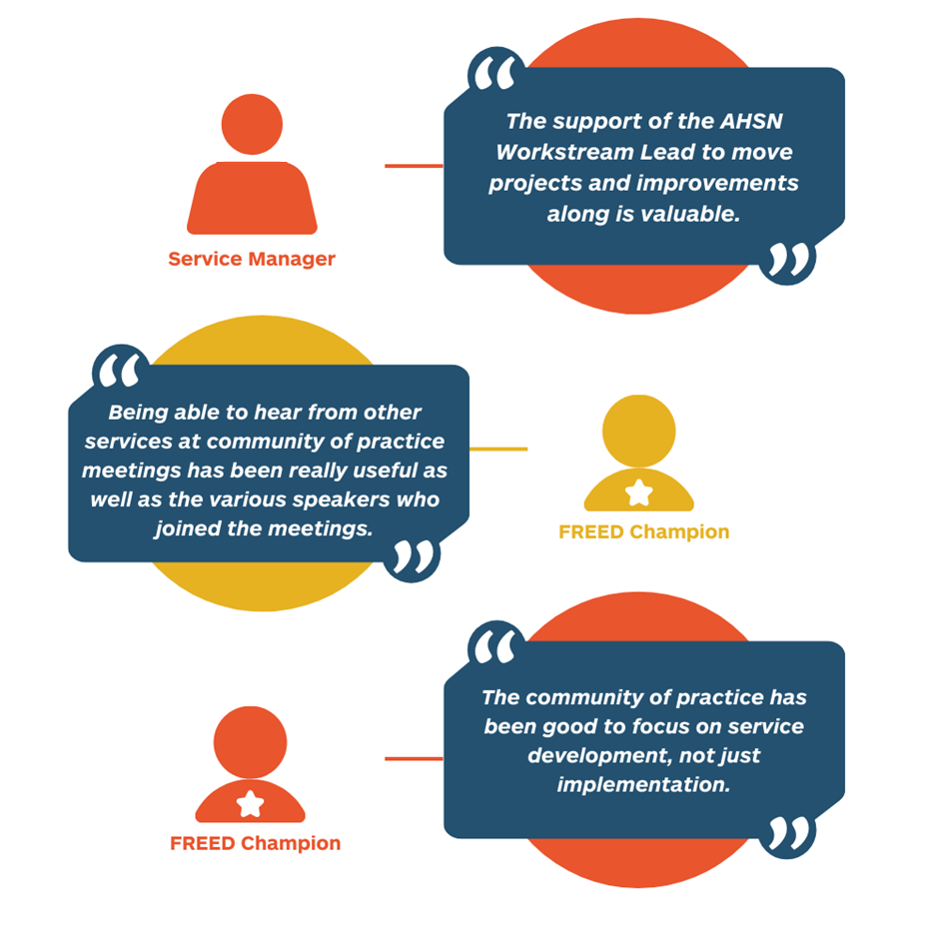

Spread and adoption approach
Spread and adoption was achieved using a hub and spoke model. The national AHSN programme team maintained contact with all 15 AHSNs to provide support as needed. A long-term collaboration approach was formed with local, regional and national stakeholders, building relationships, sharing evidence and learning, and developing a sense of being part of a network, or positive movement, which was pivotal to spread and adoption.

Figure 9. Spread and adoption methodology:
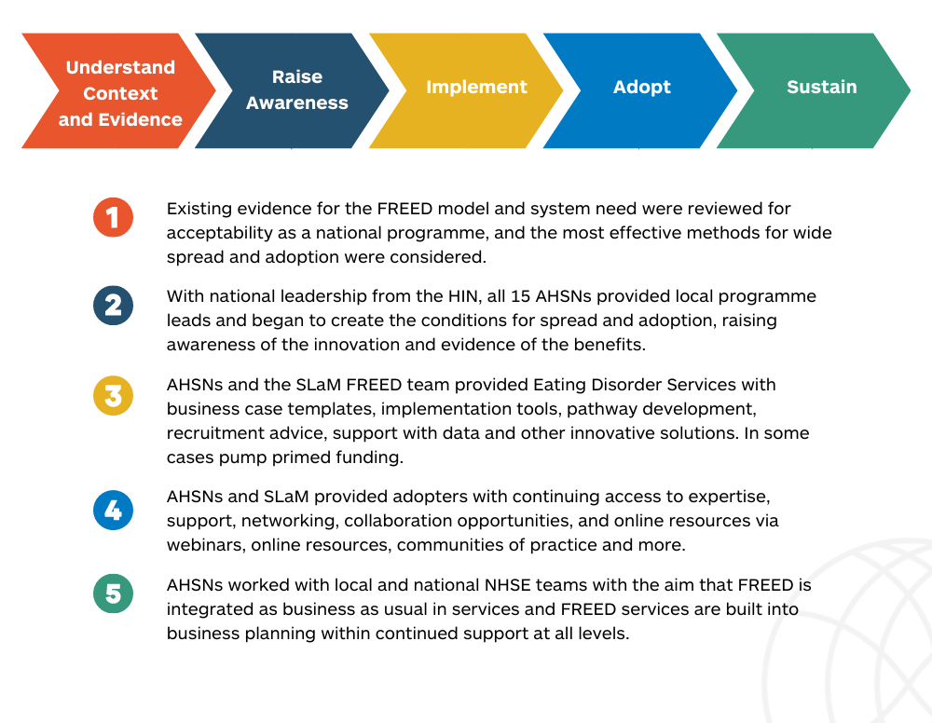
Table 4. Example activities of the national programme team:

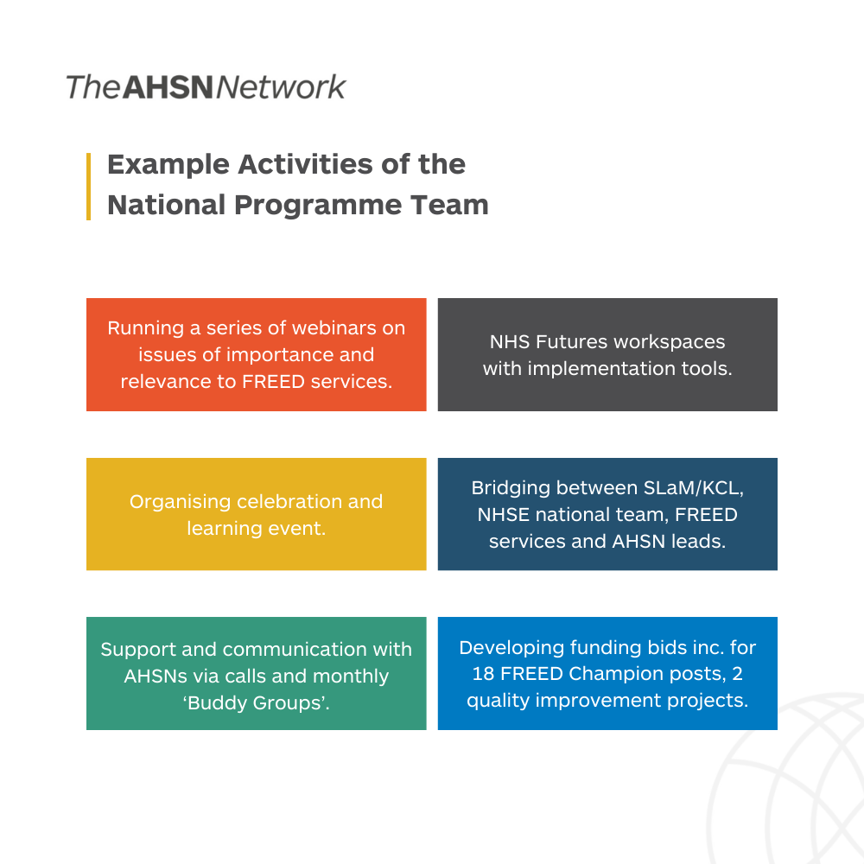

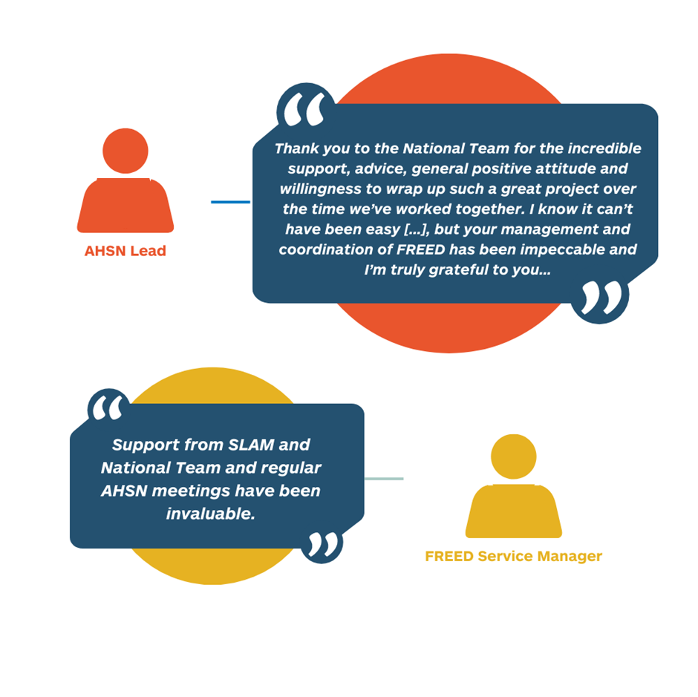

Each of the 15 AHSNs provided at least one Early Intervention Eating Disorders Programme Lead to create conditions for adoption via a ‘long collaboration’ approach. This resourcing was variable throughout the duration of the programme, with movement of staff and resourcing need, but at all times there was at least one EIED lead in each AHSN.

Table 5. Example activities of local AHSNs:

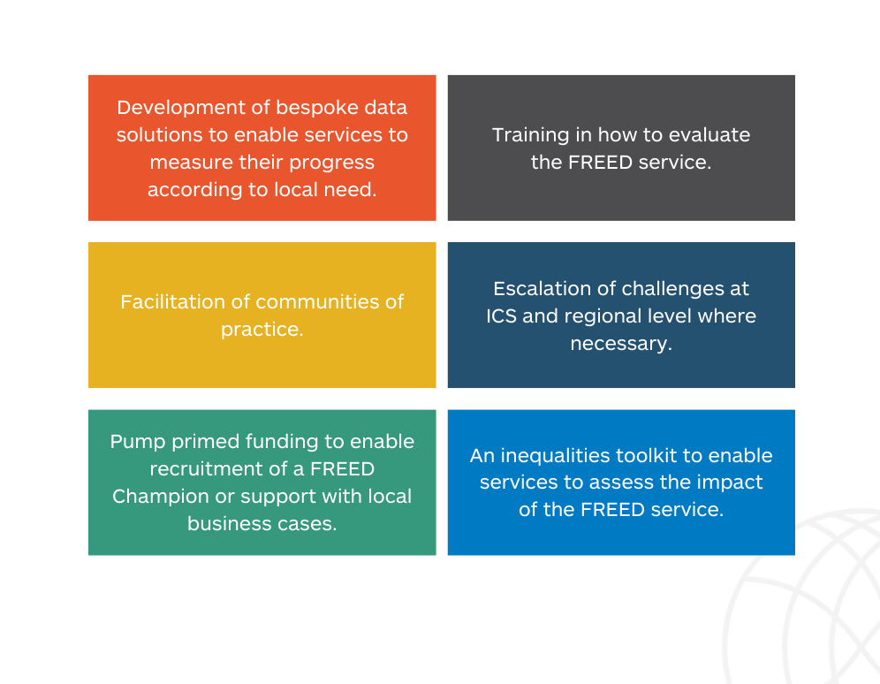

Innovation
Locally, services explored innovation to fit their specific service needs. AHSNs supported this by sharing learning, for example a webinar was held in the South East (Oxford, Wessex and Kent Surrey Sussex AHSNs) which identified potentially useful innovation. Eastern and Imperial AHSNs supported development of a podcast to support patients who were waiting for treatment. Kent Surrey and Sussex AHSN developed a toolkit to assess and challenge impact on health inequalities. Communities of practice nationally supported sharing learning and innovation.

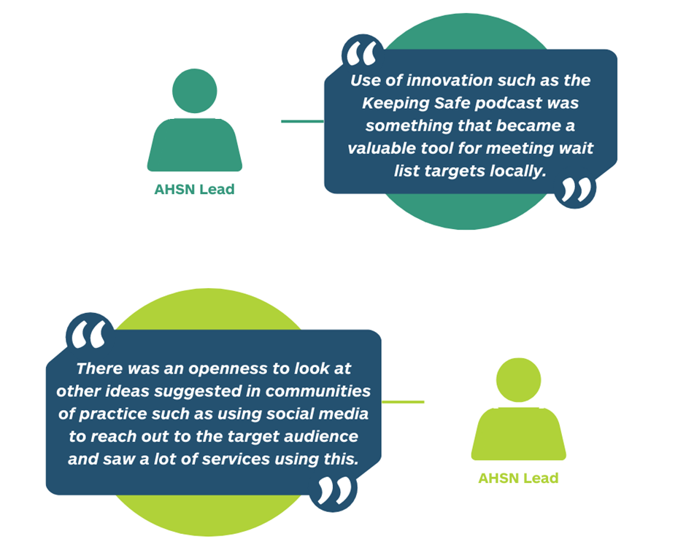
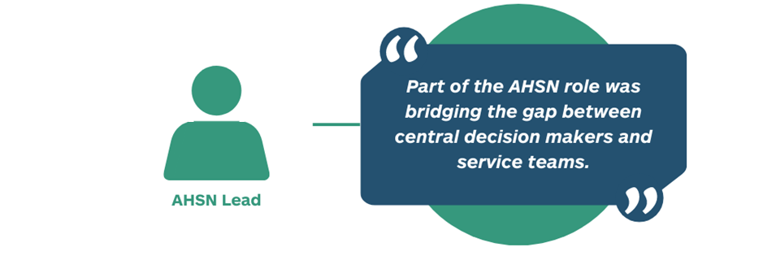

Sustainability
Whilst there is near-unanimous support for early intervention in eating disorders, and for the FREED model, sustainability of FREED services following the national programme is a mixed picture. Some services have confirmed indefinite funding for a FREED Champion and mini team, whilst others are facing resource pressures which necessitate diversion of funds to other areas. NHSE have confirmed support for the centralized FREED network to continue supporting local FREED services.

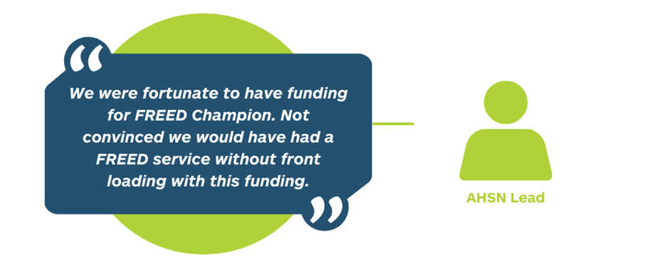

Example comments made by AHSN leads and services on sustainability include:

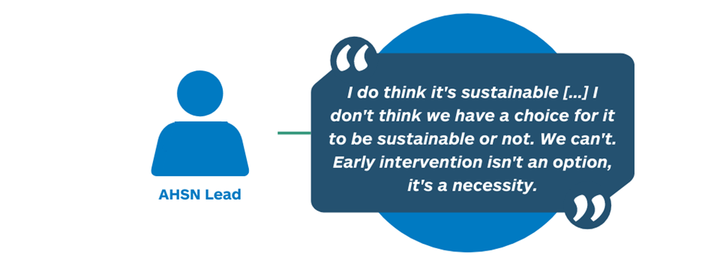

Multiple AHSN leads and FREED service staff felt FREED was key to reducing pressure on services in the long term, thus securing service sustainability.

Key learning points for future programmes
A number of key themes for learning which could inform future programmes of this kind had emerged by the conclusion of the National Programme. These include:

- The COVID-19 pandemic, a wholly unanticipated national and international emergency, had a significant impact on delivery, capacity and ways of working. Under normal circumstances, without social distancing restrictions, a large national programme such as this may benefit from an appropriate level of face-to-face interaction including visiting AHSNs and services on site at least once to build relationships and understand context. In addition, joining key partners for team meetings or otherwise co-locating at appropriate times could provide useful insights on pressures faced and ways of working. Such face-to-face interaction may support relationship building and mutual understanding of pressures.

- A structure of networks can be very beneficial. These could include ‘buddy groups’ for implementation leads and communities of practice for service leads on a regional level, as well as clinical implementation supervision. Feedback from all parties repeatedly reported how useful and supportive such groups were in terms of shared learning, sharing challenges and frustrations, and sharing good practice. Some reported that these networks were pivotal to implementation.

- Plans for sustainability should be considered from the outset and continually held as a potential aim following the programme. Whilst it is not the role of the AHSN Network to ensure or secure sustainability of a time limited spread and adoption programme, it could be beneficial to have sustainability as a standing item at board meetings or at other suitable regular intervals to assess whether future sustainability is in fact the goal, and if so how this can be achieved.

- Having a repository of resources to aid implementation in an accessible format such as NHS Futures can support not only services onboarding at various stages throughout the programme, but also AHSN leads and others joining the programme part way through. These need to be accessible and logically laid out. Many reported the FREED NHS Futures workspace to have been beneficial, and the chat function allowed people to ask questions on issues which may not have previously arisen.

- Where there are multiple data collectors, naming conventions and metrics should be agreed and adhered to universally where possible. This should include whether reporting is at site, service, provider, Trust, or ICS level.

- Collecting data on the impact of the programme on inequalities could form part of the conditions of adopting an innovation under an AHSN programme. Given the current paucity of consistent national level inequalities data this would support use of data to build a picture which in turn can inform action to reduce inequalities.

- Building-in time for evaluation of the programme following completion allows for full and complete data to be collected and analysed.

References and evidence

- FREED (2023) FREED from ED. Available at: https://freedfromed.co.uk/ (Accessed 14 June 2023)

- NHS (2023) Early Intervention in Psychosis https://www.england.nhs.uk/south/our-work/mental-health/early-intervention-in-psychosis/

- Treasure J, Duarte TA, Schmidt U. Eating disorders. Lancet. 2020 Mar14;395(10227):899-911.

- Royal College of Psychiatrists. (2019) Position Statement on Early Intervention for Eating Disorders. Available at ps03_19.pdf (rcpsych.ac.uk) (accessed 14/06/23)

- Schmidt U, Brown A, McClelland J, Glennon D, Mountford VA. Will a comprehensive, person-centered, team-based early intervention approach to first episode illness improve outcomes in eating disorders? Int J Eat Disord. 2016 Apr;49(4):374-7. doi: 10.1002/eat.22519. Epub 2016 Mar 28. PMID: 27084796.

- Austin A, Flynn M, Richards K, Hodsoll J, Duarte TA, Robinson P, Kelly J, Schmidt U. Duration of untreated eating disorder and relationship to outcomes: A systematic review of the literature. Eur Eat Disord Rev. 2021 May;29(3):329-345. doi:10.1002/erv.2745. Epub 2020 Jun 23. PMID: 32578311.

- The Health Foundation (2023). FREED-UP: First episode and rapid early intervention service for young people with eating disorders - upscaled. Available at: https://www.health.org.uk/improvement-projects/freed-up-first-episode-and-rapid-early-intervention-service-for-young-people (Accessed August 2023)

- The Children’s Commissioner (2023) Young People with Eating Disorders in England on the Rise. Available at: Young people with eating disorders in England on the rise | Children's Commissioner for England (childrenscommissioner.gov.uk)

- South London and Maudsley NHS Foundation Trust (2015) Shine 2014 final report: Development and Evaluation of a First Episode and Rapid Early Intervention Service for Eating Disorders (FREED)

- Austin A, Flynn M, Shearer J, Long M, Allen K, Mountford VA, Glennon D, Grant N, Brown A, Franklin-Smith M, Schelhase M, Jones WR, Brady G, Nunes N, Connan F, Mahony K, Serpell L, Schmidt U. (2021) The First Episode Rapid Early Intervention for Eating Disorders - Upscaled study: Clinical outcomes. Early Interv Psychiatry. 2022 Jan;16(1):97-105. doi: 10.1111/eip.13139. Epub 2021 Mar 29. PMID: 33781000; PMCID: PMC9291113.

- NHS Innovation Accelerator (2017) Meet our Alumni: Karina Allen. Available at: https://nhsaccelerator.com/fellow/karina-allen/ (Accessed: 18 June 2023)

- Flynn M, Austin A, Lang K, Allen K, Bassi R, Brady G, Brown A, Connan F, Franklin-Smith M, Glennon D, Grant N, Jones WR, Kali K, Koskina A, Mahony K, Mountford V, Nunes N, Schelhase M, Serpell L, Schmidt U. (2020 rev. 2021) Assessing the impact of First Episode Rapid Early Intervention for Eating Disorders on duration of untreated eating disorder: A multi-centre quasi-experimental study. Eur Eat Disord Rev. 2021 May;29(3):458-471. doi: 10.1002/erv.2797. Epub 2020 Oct 28. PMID: 33112472.

- Hyam L, Torkelson C, Richards K, Semple A, Allen K, Owens J, Jackson A, Semple L, Glennon D, Di Clemente G, Schmidt U. (2023). ’Early intervention isn't an option, it's a necessity’: Learning from Implementation Facilitators and Challenges from the Rapid Scaling of an Early Intervention Eating Disorders Programme in England. Submitted for publication.

- Brown A, McClelland J, Boysen E, Mountford V, Glennon D, Schmidt U (2016). The FREED Project (first episode and rapid early intervention in eating disorders): service model, feasibility and acceptability. Early Intervention in Psychiatry, 12, 250-257.

- McClelland J, Hodsoll J, Brown A, Lang K, Boysen E, Flynn M, Mountford VA, Glennon D, Schmidt U. A pilot evaluation of a novel First Episode and Rapid Early Intervention service for Eating Disorders (FREED). Eur Eat Disord Rev. 2018 Mar;26(2):129-140. doi: 10.1002/erv.2579. PMID: 29460477.

Katie Richards (2023). Implementation processes and outcomes in early intervention for eating disorders: A multi-method investigation. Unpublished PhD Thesis, King’s College London.
- Fukutomi A, Austin A, McClelland J, Brown A, Glennon D, Mountford V, Grant N, Allen K, Schmidt U. First episode rapid early intervention for eating disorders: A two-year follow-up. Early Interv Psychiatry. 2020 Feb;14(1):137-141. doi: 10.1111/eip.12881. Epub 2019 Oct 15. PMID: 31617325.

- Potterton R, Austin A, Flynn M, Allen K, Lawrence V, Mountford V, Glennon D, Grant N, Brown A, Franklin-Smith M, Schelhase M, Jones WR, Brady G, Nunes N, Connan F, Mahony K, Serpell L, Schmidt U. "I'm truly free from my eating disorder": Emerging adults' experiences of FREED, an early intervention service model and care pathway for eating disorders. J Eat Disord. 2021 Jan 6;9(1):3. doi: 10.1186/s40337-020-00354-9. PMID: 33407906; PMCID: PMC7789709.

- Hyam, L., Richards, K. L., Allen, K. L., & Schmidt, U. (2023). The impact of the COVID-19 pandemic on referral numbers, diagnostic mix, and symptom severity in Eating Disorder Early Intervention Services in England. International Journal of Eating Disorders, 56( 1), 269– 275. https://doi.org/10.1002/eat.23836

Appendix 1. Feedback from AHSN Leads
A series of feedback sessions were conducted with AHSN Leads to deep-dive their perspectives of the EIED programme and experience of supporting FREED in services. The feedback given was:
What went well? | What could we have done differently?
Data collection theme
- “The ask for data collection was sensible and sufficient” | - “Data tracker was reported as onerous by some services. Had from the beginning there been an explanation of the tracker, its purpose and using user feedback to develop it would have been very beneficial (even light touch)”  - “It would have been better if the tracker had been aligned to the NHSE data collection”  - “Collecting more inequalities data”
Response from services
- “It helps that FREED is not a complete overhaul of pathways”  - “SLaM training/implementation supervision has been positively received by FREED Champions”  - “We have seen lots of interest from CAMHS and universities. The word is being spread far and wide and a lot of people want to be part of FREED”  - “There is solidarity among FREED Champions and willingness to share best practice”  - “Catalyst for success was the £35k for FREED champion recruitment ‘spoonful of sugar’. Had this funding not been provided would have experienced severe challenges with recruitment.”  - “We’ve not seen enthusiasm for the model lacking, the want to do it has always been there” | - “Workarounds for non NHS providers. Services which weren’t NHS trusts weren’t able to access MANTRA training. Discussed with HEE but never quite got resolved”  - “Ensure ringfencing of FREED champion time against business as usual. Get the service managers to commit to dedicating FREED Champion time only”
Relationship building/local support theme
- “The AHSN offered some funding for transition from CAMHS to adults and the programme was flexible enough to allow that when it was what was needed to implement FREED”  - “Community of practice events were a space where people could ask questions that they might not want to ask other forums. It didn’t matter what stage you were at.”  - “We managed in spite of external circumstances. Taking a hard escalation approach might have been damaging to the local relationship. It took 2/3 years of massaging the relationship to get to adoption”  - “We were fortunate to have funding for FREED Champion. Not convinced we would have had a FREED service without front loading with this funding”  - “Being linked in to the network was vital for support and learning from others”  - “SLaM engagement was pivotal and SLaM were great at quelling any nerves around roll out”  - “There was a wealth of resources shared. [AHSN leads] were coming in at various points throughout the programme and having lots of information and people we could contact was useful” | - “ When creating conditions for change a lot is about the individuals. Luck or digging for people who will champion. If we can find one or two people we can create engagement with then that can permeate more widely”  - “If more AHSNs had been able to identify sources of funding/fund FREED roles, which is what was needed early on”  - “If more AHSNs had been able to identify sources of funding/fund FREED roles, which is what was needed early on”  - “Sites could have come on board sooner if training was available more regularly”  - “There was a challenge of recruiting staff in a geographically remote and highly stressful environment. There is a clear need to support services to outline a career trajectory if one were to join the services”
AHSN programme
- “In a future programme we would want similar consistency in the programme itself as we had with FREED because it gives confidence as programme”  - “The fact that we [the AHSNs] didn’t cut and run a year ago was a credit to us”  - “We had a real understanding that what we were trying to achieve”  - “There wasn’t pressure to achieve targets during roll out during COVID”  - “Business case, training etc resources were adequate to make the case and there’s not much we can do if a Trust is in special measures/business continuity/simply not FREED ready”  - “AHSN leads willingness to engage has resulted in good cross pollination and solidarity”  - “Having a network and wider pool of info and experience to pull on is fantastic because those sites have a much bigger picture available”  - “It has been a very clear programme, both the programme structure and innovation”  - “The HIN role was pivotal in terms of clear messaging and clarity of mission” | - “It would have helped to keep the project manager/AHSN lead consistent throughout as we lose some of the knowledge and gains by changing”  - “It has been a difficult time for services to move on and adopt a new pathway. The AHSNs persevered to get FREED onto the agenda by sharing resources and supporting. The key is to start small, start somewhere”  - “Circumstances within which we were operating were very challenging. This began pre-COVID but then there was enormous disruption. It’s difficult to say what we would do differently because the circumstances are different post-COVID”  - “Having an example of what resource is needed to get started – i.e. mini team. Remembering to provide this information for services coming in at different stages if this was provided early on.  - “If the Operational Agreement had been scrutinised in detail to identify potential blockers that might have spared some time and energy”  - “If we hadn’t had COVID at the outset of the programme. FREED implementation has been vastly affected and early intervention has been limited because people were at home”  - “We need ways to quickly upskill people who join half way through the programme”  - “It was an opportunity missed to do anti-stigma outreach campaigning. EDs are conditions that are deeply misunderstood. If COVID hadn’t struck we likely would have had the opportunity to do this”  - “AHSNs needed more time and resources for linking in to the right people”

Appendix 2. FREED spread and adoption by Mental Health Trust*:
Table showing spread and adoption of FREED as at end March 2023, with additional column for updates where services were able to progress just outside of the national programme.

Trust | Stage of Adoption Q4 (Jan-March) 2023 | Update Q1 (April – June) 2023 | AHSN
Avon and Wiltshire Mental Health Partnership NHS Trust | Adopted |  | West of England AHSN
Barnet, Enfield and Haringey Mental Health NHS Trust | Implementation |  | University College London Partners
Berkshire Healthcare NHS Foundation Trust | Adopted |  | Oxford AHSN
Birmingham And Solihull Mental Health NHS Foundation Trust | Implementation |  | West Midlands AHSN
Birmingham Women's and Children's NHS Foundation Trust | Adopted |  | West Midlands AHSN
Black Country Healthcare NHS Foundation Trust | Adopted |  | West Midlands AHSN
Bradford District Care NHS Foundation Trust | Adopted |  | Yorkshire and Humber AHSN
Cambridgeshire and Peterborough NHS Foundation Trust | Adopted |  | Eastern AHSN
Camden and Islington NHS Foundation Trust | Not applicable |  | University College London Partners
Central and North West London NHS Foundation Trust | Adopted |  | Imperial College Health Partners
Cheshire and Wirral Partnership NHS Foundation Trust | Adopted |  | Innovation Agency
Cornwall Partnership NHS Foundation Trust | Adopted |  | South West AHSN
Coventry and Warwickshire Partnership NHS Trust | Not applicable |  | West Midlands AHSN
Cumbria, Northumberland, Tyne and Wear NHS Foundation Trust | Adopted |  | North East and North Cumbria AHSN
Derbyshire Healthcare NHS Foundation Trust | Adopted |  | East Midlands AHSN
Devon Partnership NHS Trust | Adopted |  | South West
Dorset HealthCare University NHS Foundation Trust | Adopted |  | Wessex
East London NHS Foundation Trust | Decision |  | University College London Partners
Essex Partnership University NHS Foundation Trust | Adopted |  | University College London Partners
Gloucestershire Health and Care NHS Foundation Trust | Implementation | Service launched | West of England
Greater Manchester Mental Health NHS Foundation Trust | Adopted |  | Health Innovation Manchester
Herefordshire and Worcestershire Health and Care NHS Trust | Implementation |  | West Midlands
Hertfordshire Partnership NHS Foundation Trust | Adopted |  | Eastern
Humber Teaching NHS Foundation Trust | Adopted |  | Yorkshire and Humber
Isle Of Wight NHS Trust | Decision |  | Wessex
Kent and Medway NHS and Social Care Partnership Trust | Not applicable |  | KSS
Lancashire and South Cumbria NHS Foundation Trust | Implementation |  | Innovation Agency
Leeds and York Partnership NHS Foundation Trust | Adopted |  | Yorkshire and Humber
Leicestershire Partnership NHS Trust | Adopted |  | East Midlands
Lincolnshire Partnership NHS Foundation Trust | Adopted |  | East Midlands/Yorkshire and Humber
Mersey Care NHS Foundation Trust | Adopted |  | Innovation Agency
Midlands Partnership NHS Foundation Trust | Implementation |  | West Midlands
Norfolk And Suffolk NHS Foundation Trust | Adopted |  | Eastern
North Cumbria Integrated Care NHS Foundation Trust | Not applicable |  | North East and North Cumbria
North East London NHS Foundation Trust | Adopted |  | University College London Partners
North Staffordshire Combined Healthcare NHS Trust | Not applicable | Preparing for adoption | West Midlands
North West Boroughs Healthcare NHS Foundation Trust | Adopted |  | Innovation Agency
Northamptonshire Healthcare NHS Foundation Trust | Adopted |  | East Midlands
Nottinghamshire Healthcare NHS Foundation Trust | Adopted |  | East Midlands
Oxford Health NHS Foundation Trust | Adopted |  | Oxford
Oxleas NHS Foundation Trust | Adopted |  | HIN
Pennine Care NHS Foundation Trust | Adopted |  | Health Innovation Manchester
Rotherham Doncaster and South Humber NHS Foundation Trust | Not applicable |  | Yorkshire and Humber
Sheffield Health and Social Care NHS Foundation Trust | Adopted |  | Yorkshire and Humber
Solent NHS Trust | Not applicable |  | Wessex
Somerset NHS Foundation Trust | Adopted |  | South West
South London and Maudsley NHS Foundation Trust | Adopted |  | HIN
South West London and St George's Mental Health NHS Trust | Adopted |  | HIN
South West Yorkshire Partnership NHS Foundation Trust | Adopted |  | Yorkshire and Humber
Southern Health NHS Foundation Trust | Adopted |  | Wessex
Surrey and Borders Partnership NHS Foundation Trust | Adopted |  | KSS
Sussex Partnership NHS Foundation Trust | Decision | Full service re-launched | KSS
Tees, Esk And Wear Valleys NHS Foundation Trust | Adopted |  | North East and North Cumbria/Yorkshire and Humber
West London NHS Trust | Adopted |  | Imperial College Health Partners
*Based on information provided April/May 2023. Number of services differs from number of Mental Health Trusts. Services noted as ‘not applicable’ commission eating disorder services from a separate provider. Sites noted as ‘decision’ temporarily lack resource to adopt. For full up to date service-level information contact services directly.

